**Description**

Crowdfunding platforms like Kickstarter and Indiegogo have been growing in success and popularity since the late 2000s. From independent content creators to famous celebrities, more and more people are using crowdfunding to launch new products and generate buzz, but not every project has found success.

To receive funding, the project must meet or exceed an initial goal. In this challenge, I organized and analyzed a database of 1,000 sample projects to uncover any hidden trends.

**Built with**

* Pivot table

**Conclusions**

1. Theatre, film & video and music category were the most successfully funded project. They also stand a high chance of failing and being cancelled. On the other hand, journalism was the least successful category. In fact, all campaigns under journalism were cancelled.
2. The most interesting observation is that donations received in the theatre category were used towards play production. This contributed to the high success experienced under theatre category.
3. The most successful campaigns were those launched around May spanning till July. Whereas the campaigns launched towards the yuletide were the least successful.

**Limitations of Dataset**

1. Not all genres of music were represented in the category.

ii.) The category theatre could also be subcategorized into filming, music etc.

iii.) There are no data on how many campaigns were scams.

**Suggestions for additional tables of graph**

i.) Average donation for each sub-category

ii.) Sub-categories within each country

iii.) Outcome for each country

iv.) Launch dates for each country.

**Variability of Data**

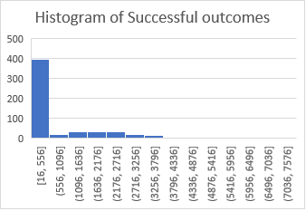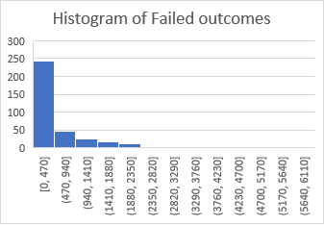Given the unsymmetric data distribution for both the failed and successful outcomes (i.e., data skewed towards the left), the median may be more useful in summarizing the data because the mean might have been distorted by outliers. Each data is about 1.5 times deviated from the mean and the higher mean compared to the median could be driven by the large maximum numbers.

**References**

Data for this dataset was generated by edX Boot Camps LLC and is intended for educational purposes only.